DENTCARE AI

Automated Dental Pathologies Detection
DentCare AI is a comprehensive diagnostic system designed to assist dentists by automating the detection of dental issues like Cavities, Fillings, Implants, and Impacted Teeth. The system processes both Clinical Images and X-ray (OPG) Images using state-of-the-art Deep Learning models.

Methodology
The project follows a dual-stream pipeline to handle different data types:
- Clinical Stream: Focuses on visible pathologies using Mask Annotation and Normalization.
- X-ray Stream: Processes OPG images with advanced feature extraction and class balancing.
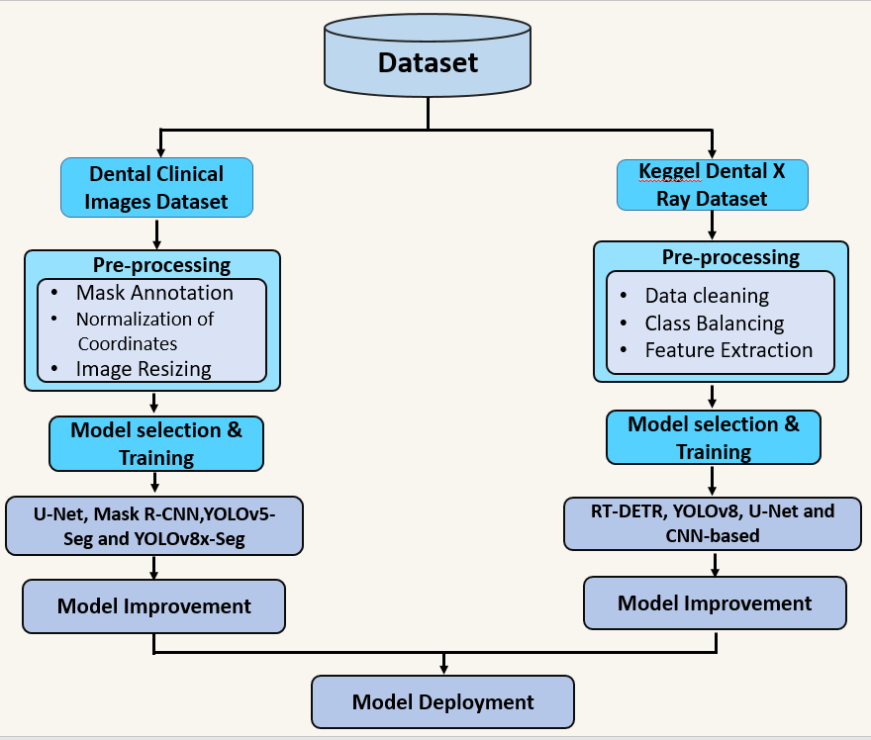

Performance & Results

1. Clinical Dataset Results
We experimented with multiple YOLOv8 variants. YOLOv8l-seg (Large) achieved the best performance for instance segmentation.

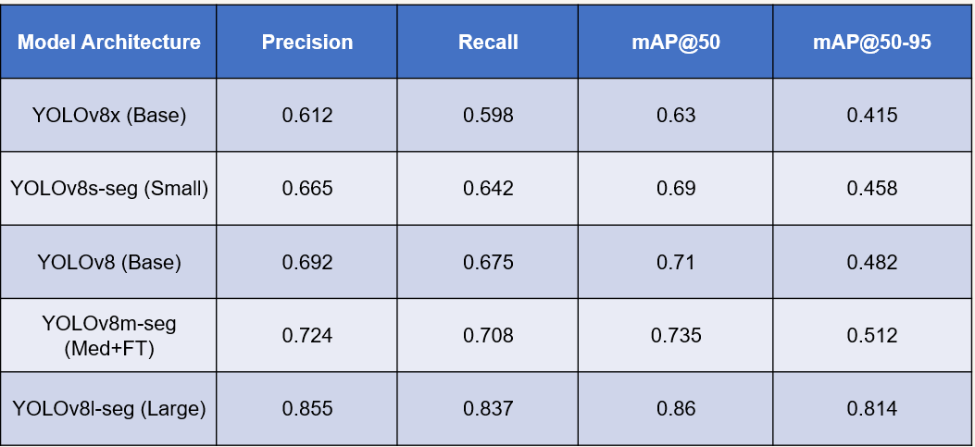

2. X-ray (OPG) Dataset Results
For X-ray analysis, YOLOv8n-OBB (Oriented Bounding Boxes) outperformed other architectures, including RT-DETR and standard CNNs.

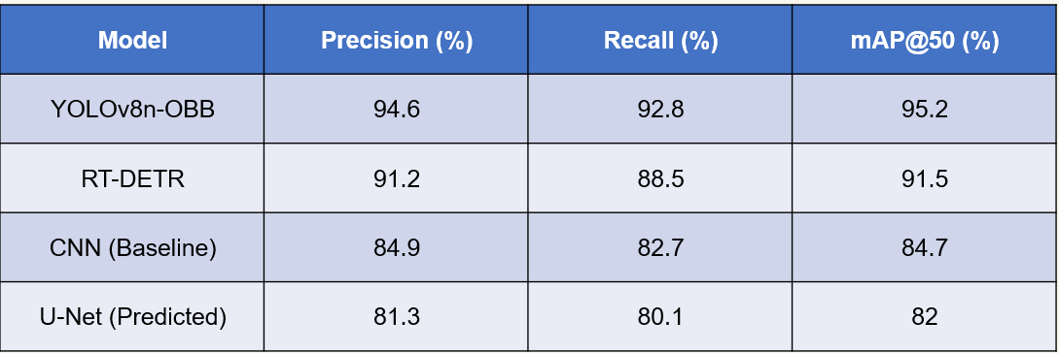

Key Features
- Dual-Model Support: Specialized models for both clinical photos and radiographs.
- High Accuracy: Up to 95.2% mAP on X-ray datasets.
- Real-time Assistance: Designed for rapid inference to support clinical decision-making.
- Full-Stack Integration: Backend developed in [Flask/Django] with a responsive frontend.

Repository Structure
- /backend: API and Inference logic.
- /frontend: User Dashboard code.
- /models: Trained .pt weights for YOLOv8 and RT-DETR.
- /docs: Methodology diagrams, result tables, and performance graphs.

Developed as a Final Year Project at UET Mardan.

